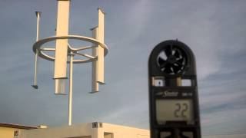

**Welcome to the New England Business Community; Farmers, Entrepreneurs, Small Businesses, Non-Profits, Municipalities, Composters, Beekeepers, Sustainability Directors, Unions, Trade Associations, Waste Haulers, Fuel Companies, Food Producers and Energy Companies.**

**Come and learn how the different facets of the sustainability industry can drive new or better cash-flows for your business, starting now.**

**Early registration discount up to 20% off available at the website**

**John Hays- Marketing Consultant**

John Hays is a marketing consultant for vendors in the sustainable environmental and energy arenas.  John will be speaking about a game changing vertical axis wind turbine which will revolutionize the wind turbine industry. Farmers, home owners, business owners, town managers and anyone interested in grid neutral electricity, need to learn about this Revolutionary Composite Vertical Wind Turbine.



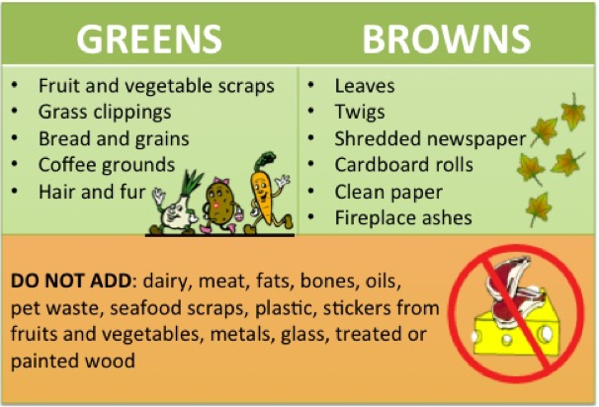

**Greg Gerritt- Environmental Council**

Composting is done in many forms - the techniques, tools, equipment, and systems have numerous variations. Greg has provided many conferences, and has many years of personal experience using these techniques and systems which he will share with you. His educational grasp of the composting process is outstanding, and will provide insight on methods. temperatures and processes, including warnings for such items as pathogens and insect infestations.

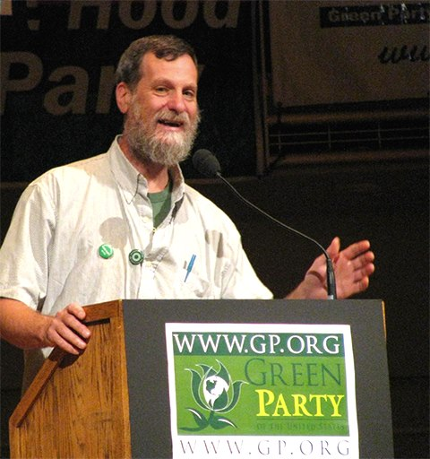

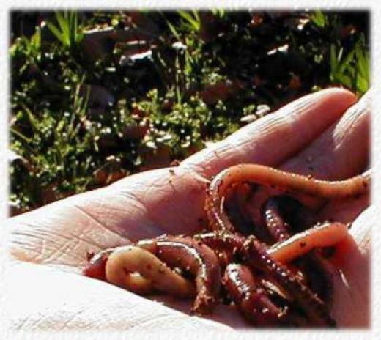

**George Mingin – Vermiculture**

George Mingin is one of the world’s leading experts of Vermiculture, which is a more formal term for worm farming. His presentation describes the benefits of these small, yet valuable, wondrous creatures, and the different breeds he uses.  George is Australia’s biggest worm farmer, and the third largest worm farmer in the world. It is a rare occasion to have a person of George’s magnitude to speak and share his knowledge on this environmentally important topic.

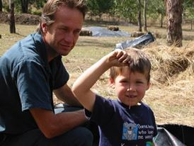

[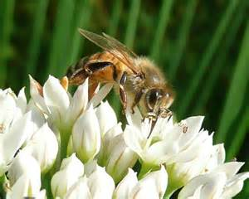](https://www.bing.com/images/search?q=betty+mencucci&view=detailv2&qpvt=betty+mencucci&id=2FF44BAFEEBC58EEA75372871CCAFC501E18159D&selectedIndex=4&ccid=IoYBJRdM&simid=608006742770845713&thid=OIP.M22860125174c4f91c133759111420bc2o0)

**Betty Mencucci – Apiculture**

**Beekeeping & Techniques**

Apiculture is the science of beekeeping - the use of bees for pollinating flowers and crops - vital to our food supply and very important to our economy and for job opportunities at all levels. Betty, is a modest person who is very dedicated to her students and college. This amazing subject matter will prove greatly rewarding for those who want to expand their educational horizon of the bee community, and to farmers who want to produce new income streams.

[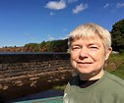](https://www.bing.com/images/search?q=betty+mencucci&id=ECDECBE73B097E9F637B16FB03450348CC6F38EC&FORM=IQFRBA)

**Mike Sokoll - Sustainable Business Financing & Solar**

Mike has been involved in leasing and financing of equipment since 2006. Adding more funding options and sources has allowed Atlantic to facilitate a broad range of clients. Learning about the technologies and understanding the markets to find the funding required takes time which has paid off in the vast list contacts.

Mike worked with a client that made Solar Panels in Massachusetts which peaked his interest. He will show you the basics of a solar project and use a simple model he has developed to help you understand how the numbers all work. These same metrics can be applied to the other sustainable businesses that the conference is highlighting.

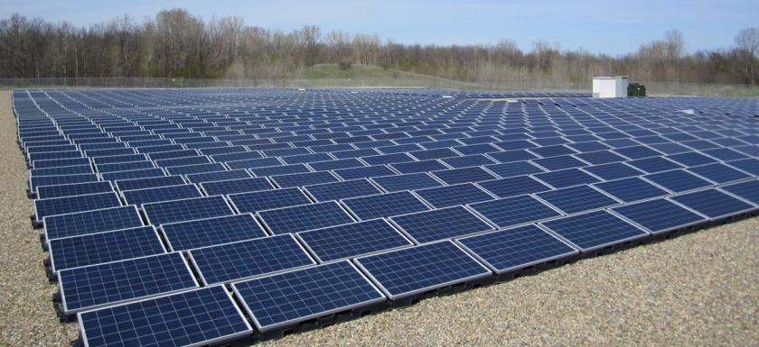

[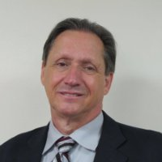](https://www.linkedin.com/start/view-full-profile?_ed=0_QPf54EACZj9ID4AaTz0ZP2f3xB4s1FYbi9Vgvryd_12U5pHDyJG-M5Q8vhjL0XAN&trk=pprof-0-ts-view_full-0)

**Kathy Parker – Accountant Services**

Kathy Parker, CPA, is a Partner in Rodman CPAs, a firm that specializes in tax advisory services and business strategy for small and medium sized companies. The firm has a dedicated "Green Team" Renewable Energy and Clean Technology Practice, where Kathy is a client adviser and advocate, providing expert green energy tax advisory, accounting services, and business strategy for companies and investors in renewable energy production and energy efficiency.

[](https://www.linkedin.com/pulse/looking-experienced-tax-professionals-kathy-parker?articleId=6166659759211638785#comments-6166659759211638785&trk=prof-post)

[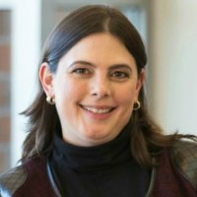](https://www.linkedin.com/start/view-full-profile?_ed=0_b_al9rIFb5nZ52fJFZ8LonlAhOWjw0kkLTo0nMUEpfENnmCQrlLWZP8jFDIkG_eb&trk=pprof-0-ts-view_full-0)

**Howard Weldon, Water Purification Specialist**

Fahs Stagemyer has developed a unique method of water and air purification, as well as a method for the creation of Non-Hydrocarbon Generated Energy which can be concentrated for use in a Mobile or Stationary Energy Storage System. These methods are derived from a (Patented) process known as Precise Energy Separation (PES)™.

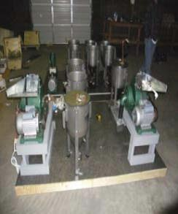

**Steve Finch- Biofuels & Ethanol**

Biofuels and ethanol are such a wide, diverse technology, and we are fortunate to have one of the world’s leading experts in the field, Steve Finch, speaking at the convention. Steve has built the largest ethanol plant in Australia, and the second largest biodiesel plant in the USA - he has made mobile machines as large as semi-trailers to as small as classroom size.

Fuels are not the only product - his machines can produce animal feed while producing fuels. If you are interested in acquiring information of how these machines work, you will receive a detailed explanation at the conference from a world class performer.

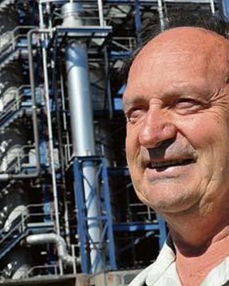

**Mike Schieck- Aquaculture -Health & Wellness**

Michael Schieck has many years of experience in the AQUACULTURE industry - the science of fish farming, with fish growth being vitally dependent on good water quality and the deployment of good decision techniques. AQUAPONICS - the science of combining fish farming and hydroponics to form a system integrating both technologies, and creating a mutual, beneficial partnership. Learn the technology in greater detail by attending this conference.

Michael has also developed more than 150 products used in the Health and Wellness industry, from organic materials currently being used in vermiculture, aquaponics and hydroponics.  This lifestyle implies less consumption of synthetic chemicals in one’s body.

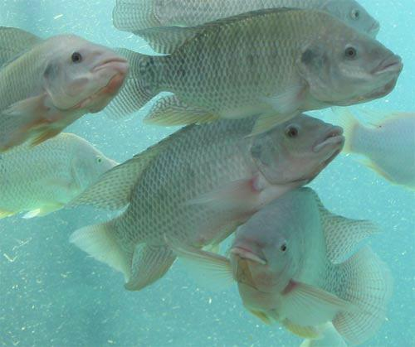

[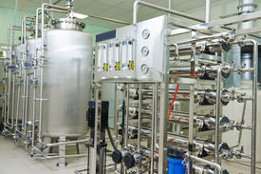](http://powerpictures.crystalgraphics.com/photos/view/cg7p0731382c/pharmaceutical_technology_equipment_facility_for_water_preparation)

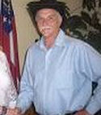

[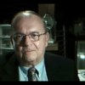](https://www.linkedin.com/in/howard-l-weldon-b6949ba5?trk=prof-samename-picture)

**Visit our vendor tables for more resources and information to strengthen your company or organization. Make your business a sustainability leader and cash-in on the economic benefits attainable from the technologies of the Northeast Sustainable Business Conference 2016**